WASHOE COUNTY DEPARTMENT
OF
JUVENILE SERVICES
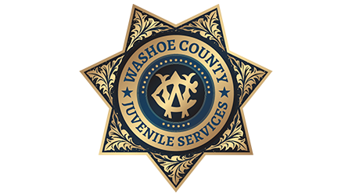
FAMILY HANDBOOK

Excellence in Juvenile Justice

Under the direction of the Family Division, Second Judicial District Court, Juvenile Services provides community probation supervision, case management, detention, and community services to court wards and youth ages 10 to 18 in Washoe County. Our juvenile justice approach is balanced by supporting positive youth and family development, community safety, and offender accountability.

Mission Statement
The mission of Juvenile Services is to promote community safety and positive youth development by providing a continuum of interventions to justice involved youth and their families.
Table of Contents
Introduction 4
Citations & Arrests 5-6
Parent Responsibilities 7
Probation Services 7
Parental Involvement 8
Community Services 9
Detention Services 11
Important notices to parents 12
Frequently asked questions 13-15
Contact information 16

INTRODUCTION
Welcome to the Family Handbook for Washoe County Department of Juvenile Services (Juvenile Services). The Department provides probation supervision, innovative case management strategies, accountability, public safety, and a safe & secure detention center to meet the interests of the juvenile, families, and community we serve.
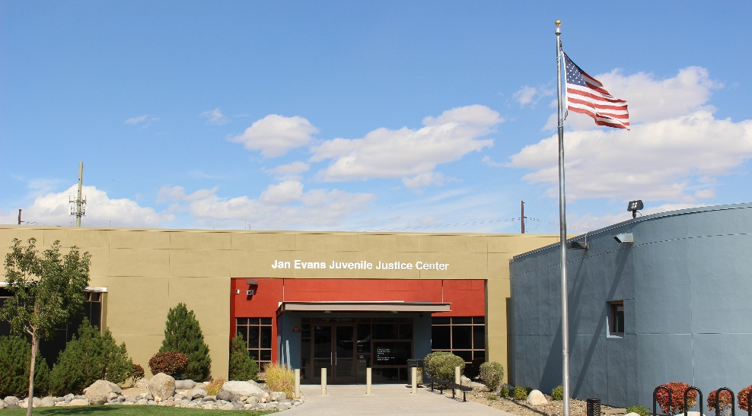
When a juvenile has contact with law enforcement, it can be overwhelming and confusing. Our goal is to help family members understand our local juvenile justice system and their rights and responsibilities. This handbook is one way to obtain information; however, we can answer any other questions that may arise through this process.
JAN EVANS JUVENILE JUSTICE CENTER
Business Hours: 8 a.m. to 5 p.m., Monday through Friday
(775) 325-7801
Detention Center Hours: 24-hours a day, 7 days a week
(775) 325-7810/7811

CITATIONS AND ARRESTS
Juvenile Services is the local government agency responsible for receiving and processing all law enforcement referrals for juveniles in Washoe County. These referrals are routed to the Department through a written citation or an arrest and booking into the local juvenile detention center known as Wittenberg Hall.

CITATIONS
The law enforcement agency that issued the juvenile a citation usually forwards a report to the Department within 7-15 business days. The citation will be processed and assigned to a member of our staff based on the severity of the offense and other factors included in the citation. This may result in one of the following actions:

- The juvenile may be scheduled for a meeting to discuss the citation with a member of our staff;
- The juvenile may be recommended for a diversion program such as informal supervision per NRS 62C.200; or
- The juvenile may be scheduled for a plea hearing in Juvenile Court.

Juvenile Services will send information explaining when and if a juvenile must appear for a meeting with a member of our staff generally within two weeks of receiving the citation. More information and instructions will be included in this document advising you and your juvenile of your rights and responsibilities.

ARREST
If a juvenile is arrested by a law enforcement agency for allegations of a delinquent act, they will be transported and booked into our local juvenile detention center (Wittenberg Hall). During the admission process, you will be contacted by telephone and advised of your responsibilities and whether your juvenile is detained pending further court action.

ARRESTED AND RELEASED
Releases may occur to a parent or guardian’s custody in the following ways:

- Release on home supervision or other conditions pending a scheduled detention hearing, usually the next business day, but no later than 72 business hours.
- Release with no restrictions pending contact with a member of our staff or future court appearances.

ARRESTED AND DETAINED
If your juvenile is arrested and detained, you will be notified of your responsibilities and advised of the time, date, and location of your juvenile’s detention hearing, usually the next business day.

Unless you choose to hire a private attorney, your juvenile will be represented at this hearing by the Public Defender’s Office. At the detention hearing the Judicial Officer will determine if your juvenile will be detained, released, or released on house arrest with or without electronic monitoring, or with special conditions pending further court appearances.

PARENT RESPONSIBILITIES

If your juvenile is cited or arrested, you will be contacted by a member of our staff and provided with further information and instructions. It is your responsibility to share accurate contact information and be an active participant in this process. You may be required to meet with a Juvenile Probation Officer or Case Manager to discuss the offense and your juvenile’s behavior. Factors such as severity of offense, prior involvement with the Department, and the results of risk and needs assessments may determine how your juvenile’s case will be handled.

If your juvenile is required to appear before the Juvenile Court, you must contact the Public Defender's Office at 775-337-4800 or retain a private attorney of your choosing.

Nevada law requires juveniles to be represented by an attorney at any court proceeding.

PROBATION DIVISION
The Probation Division is an integral part of the Washoe County Department of Juvenile Services. Juvenile Probation Officers (JPO’s) prepare investigative reports using the State of Nevada’s approved evidenced-based assessment tools, which are then used to assist the Juvenile Court in making dispositional decisions.
If a juvenile is placed on court ordered probation, they will be assigned a JPO who will provide community-based supervision using evidence-informed case management strategies based on your juvenile’s individual risks and needs. JPO’s assist juveniles with completing community service, attending school, establishing positive peer relationships, and providing referrals to programs and services that help maintain a law-abiding lifestyle. JPO’s make regular contact with juveniles in the office, in the juvenile’s home, and at school to monitor case goals, behavior, and conformance with any probation conditions or other court orders.
In some instances, juveniles may be placed under the Informal Supervision of a Case Manager pursuant to NRS 62C.200. Informal Supervision diverts juveniles from formal prosecution based on a voluntary agreement to participate in programs, services, or pay restitution to a victim. The decision to offer a juvenile Informal Supervision is based on a juvenile’s delinquency history, severity of the offense, and other factors such as the estimated risk a juvenile present to the community.
HOW CAN I GET INVOLVED?
Obtain Knowledge
You should learn as much as you can by asking questions so that you can better support your juvenile. Your engagement in this process will help your juvenile to be successful.
Participate
You are encouraged to participate in the development of your juvenile’s case plan by providing relevant information regarding your juvenile, family, values, culture, and history. Be prepared to participate in meetings, appointments, and court by providing information on progress and behaviors. Keep all paperwork in a folder (reports, letters, and notices). Also, keep notes regarding people you speak with, meetings or hearings scheduled, and other important dates and appointments. We must keep an open line of communication. Share your concerns, fears, positive aspects of your juvenile’s life as well as offer suggestions that will aid in successful programming, treatment planning and return to the community.
Advocate
You can help. We ask that you encourage your juvenile to actively participate in programs and treatment. At Juvenile Services, we find when parents are actively involved, the juvenile experiences greater success.


COMMUNITY SERVICES UNIT
The Community Services Unit provides accountability and juvenile and family development programs for juveniles and families involved in the juvenile justice system.
Accountability may include participation in community service or the Department’s Work Program. These two programs encourage service to the public which benefits the entire Washoe County community. Community service can be completed at local parks, recreation areas, governmental buildings, and non-profit agencies.
The juvenile and family development portion provides evidence-informed programming pertaining to substance use, anger management, decision making, victim awareness, strengthening families, and more. Transportation is the responsibility of the parent/guardian.
- Work Program
- Aggression Replacement Training
- Anger Management
- Changing Directions Program
- Victim Awareness Program
- Growth Program
- Early Intervention Program
- Youth Employment Program
- Substance Abuse Prevention
- Drive Program (Traffic Class)
- UDrive (Traffic Class)
- Evening Reporting Program (ERP)


DETENTION DIVISION
Wittenberg Hall is a secure holding facility for the temporary detention of juvenile offenders. NRS 62B.210 mandates that the facility be "constructed and conducted as nearly like a home as possible." Within this framework, our mission is twofold:
- Protecting the community by securely housing juveniles who may be or have been involved in activities injurious to the public.
- Providing for the safe, secure, and healthy detention of juveniles detained within the facility.

GOALS:

- To provide basic needs including shelter, food, clothing, and medical care;
- To protect juvenile’s rights during residence;
- To provide for their educational, physical, emotional, and social needs;
- To administer programs, rules, discipline, and controls in a fair and consistent manner; and,
- To nurture and encourage acceptable behavior.

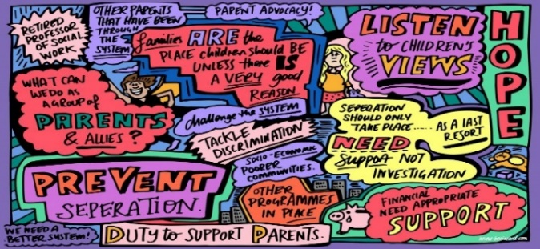
Important Notices to Parents
If your juvenile is detained, you will need to fill out the detention waiver(s) packet. These waivers allow detention staff (mental health and medical staff) to best serve your juvenile while detained at Wittenberg Hall. The packet provides information on juvenile rights, visiting, phone calls and mail.

While detained in Wittenberg Hall, your juvenile will participate in the following programs:
  - Education
  - Recreation
  - Medical Services
  - Mental Health Services
Education in our juvenile detention center is delivered by the Washoe County School District, which operates independently within the facility. Juveniles are entitled educational services that meet their individualized educational needs, ensuring continuity of learning and alignment with their existing academic plans. This partnership upholds their educational rights and supports strong academic engagement while they are in custody.
It is the goal of the detention center to work with your juvenile to provide a safe and secure setting. If your juvenile is detained and you have any questions, please contact their Probation Officer.



FREQUENTLY ASKED QUESTIONS
How long will my juvenile be involved with Juvenile Services?
The closure of your juvenile’s case depends on their behavior, progress and how quickly they complete their court or informal requirements.
Will you contact me if something happens to my juvenile while in custody?
Juvenile Services will attempt to contact you in case of any emergency in Detention. This may include a serious medical condition requiring hospitalization or emergency room treatment, attempted escape, or other serious incidents.
Can I communicate with my juvenile while detained?
Yes, you can receive phone calls, mail postcards and visit. All phone calls are recorded for security purposes. Mailed postcards, no larger than 5x7 will be accepted. All postcards must be mailed through the post office, addressed to the juvenile at the Jan Evans Juvenile Justice Center, 650 Ferrari-McLeod, Reno, NV 89512, and must include a complete return address with sender's first and last name.
To visit, you must be a parent or legal guardian, stepparent, grandparent, or biological child of the detained juvenile. Other adult(s) with whom the juvenile has established a meaningful relationship may visit upon approval of the detention facility and Probation Officer.
You must pass through security screening and have a government-approved photo ID to visit your juvenile. Please visit our Juvenile Services website for additional information about communicating with your juvenile.
To schedule a visit, you must call 775-325-7801, during regular business hours, Monday-Friday, 8:00 am to 5:00 pm, to make an appointment 24 hours in advance. No same day visits allowed.

Can I bring gifts or food to my juvenile while detained?
No. Juvenile Services is unable to accommodate this request.
How do I get in touch with my juvenile in an emergency?
In an emergency, please call Wittenberg Hall at 775-325-7810/7811.
Is information about my juvenile confidential?
Juvenile Services values the confidentiality of juveniles and families. Juvenile information in the State of Nevada is protected by law, NRS 62H.025, and can only be disclosed under specific circumstances. If you would like information regarding a release of juvenile records, please see our website.
Who do I talk to about getting updates and information?
If you have questions about how your juvenile is doing and the progress of their probationary status, please contact their Probation Officer or Case Manager.
What if my juvenile has prescribed medication and how can I provide that?
If your juvenile is detained, you will be contacted by a Juvenile Services staff member. Please inform this individual of your juvenile’s medication needs and they will instruct you as to the protocol for dropping off medication. Or you can call Wittenberg Hall directly at 775-325-7810/7811.
Where can I update contact information?
Please contact Juvenile Services at 775-325-7801 to update any change of information. You may also contact the assigned Probation Officer or Case Manager.
What happens if I am moving out of state?
Nevada participates in the Interstate Compact for Juveniles (ICJ), a cooperative effort between states to extend supervision of juveniles under Court supervision. It allows families to relocate while their juvenile remains under court supervision, thus facilitating a continuum of care and services in the receiving state. Please notify your juvenile’s Probation Officer if you plan to move out of Nevada.

CONTACT INFORMATION
Mailing Address
650 Ferrari-McLeod
Reno, NV 89512

Jan Evans Juvenile Justice Center
775-325-7801
www.washoecounty.gov/juvenilesvs

Wittenberg Hall Juvenile Detention Center
775-325-7810/7811
www.washoecounty.gov/juvenilesvs/Detention%20Services/


REV JB 02-24-26

